CREATE USER

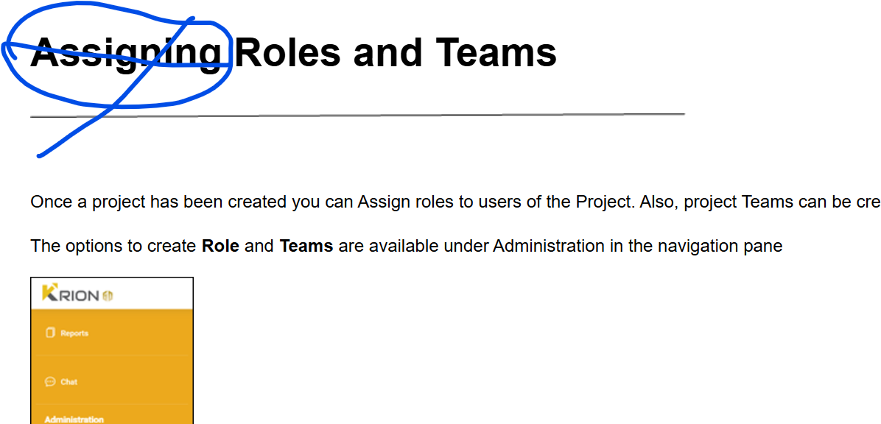

Remove Assign

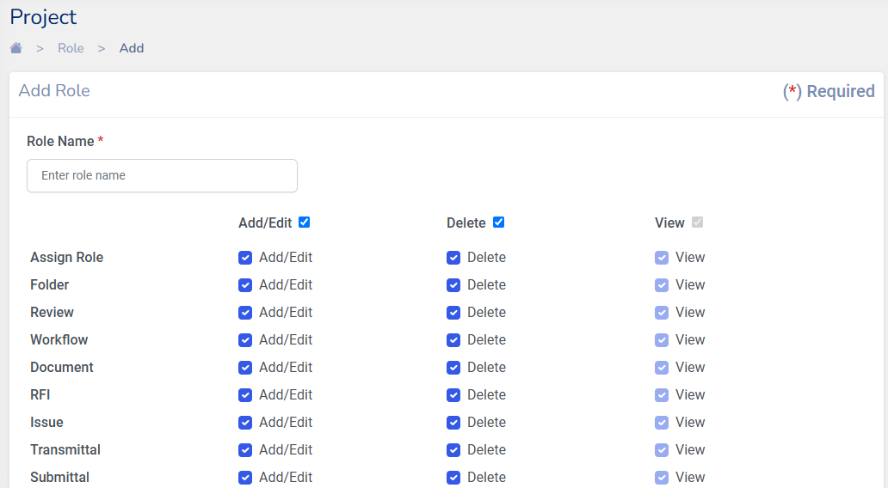

View option is missing

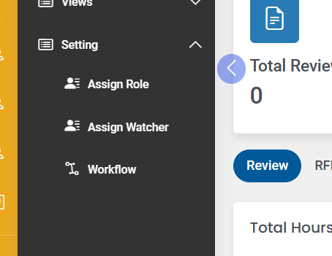

Assign watcher to be added

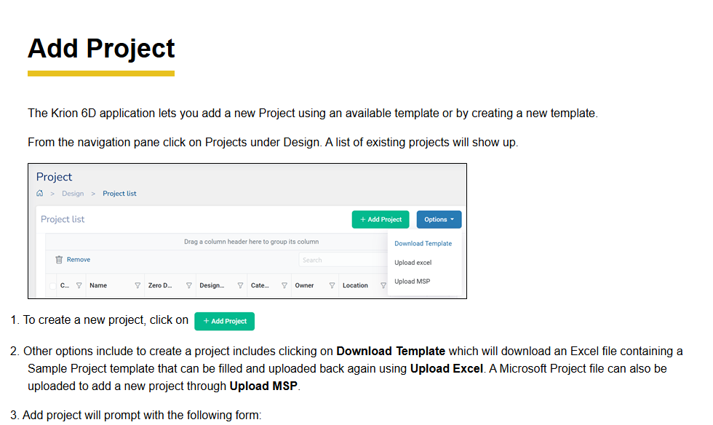

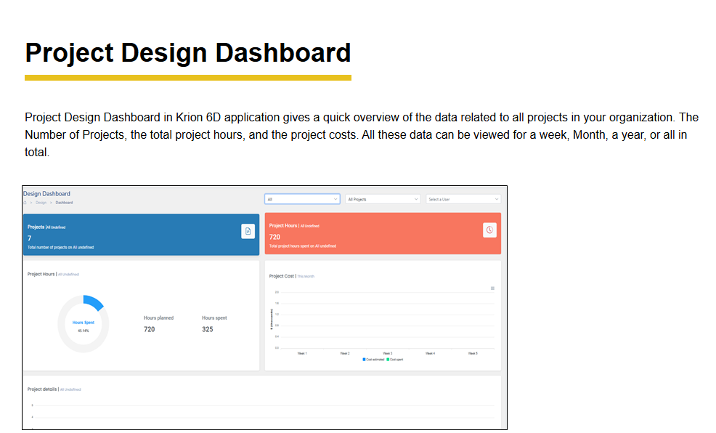

**Remove Project in the above title and align left side**

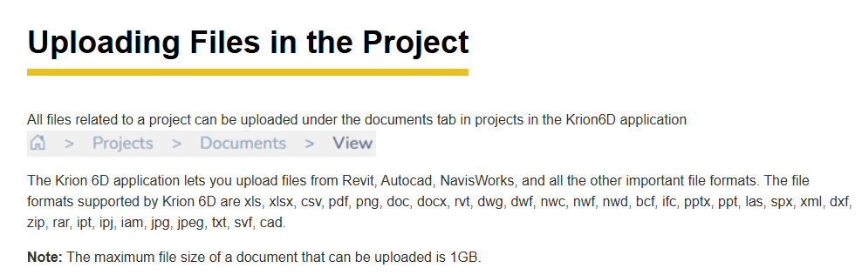

Align left side

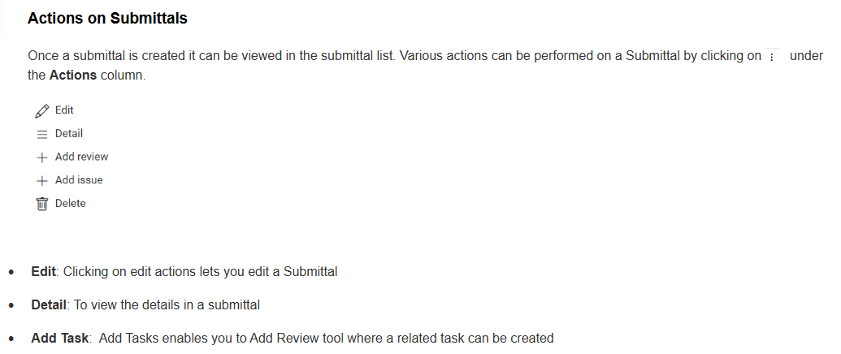

RFA SCREEN HELP DOCUMENT TO BE CREATED

WORKFLOW SCREEN TO BE UPDATED AS PER CURRENT